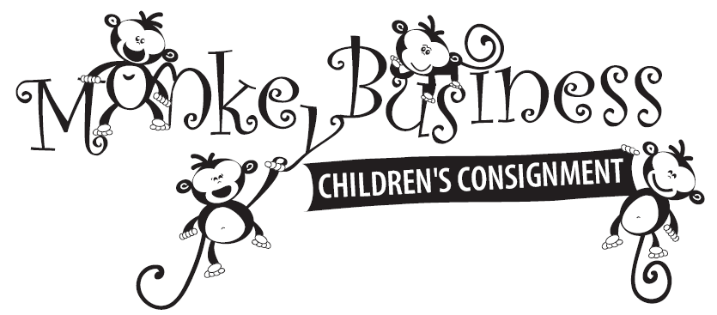
Vendor Information
Business Name: _________________________________ Contact: ______________________________________
Email Address: __________________________________ Phone #: ______________________________________
Address: _______________________________________ City, State, Zip: _________________________________
Nature/Type of Business: _____________________________________________________________________________
Marketing Opportunities: (check all that apply)
Vendor Table outside in hallway - $100 ________ Goody Bag - $25 ________Item to be placed in Goody Bag: ____
Website Ad for 6 Months - $40 ________ Total Payment: _________
Type of Payment (cash or check only): ________
------------------------------------------------------------------------------------------------------------------------------------------------------------------------
Vendor Table:
- Monkey Business will provide one 6 foot table and one chair per vendor.
- Vendors are responsible for setup and cleanup of their areas, as well as attending to the table during the sale. Setup time is Wednesday, Sept. 10, 2014 (day of drop-off) between 11am-4pm. Vendors must vacate the premises by Saturday at 4pm. Shoppers will have access to vendor tables during the following times: Wednesday, Sept. 10, 2014 (4PM-9PM) /Thurs. & Fri. Sept. 11 &12 (9am-8pm) / Saturday, Sept. 13, 2015 (9am-2pm)
- Vendors and its paid or unpaid attendees/workers agree to waive any and all claims for personal injury resulting from participation in Monkey Business Children’s Consignment Inc. events from whatever cause either foreseen or unforeseen against Monkey Business Children’s Consignment Inc., the owners and operators of Monkey Business Children’s Consignment Inc., the lessor of the space where the sales event is held, any volunteer, shopper, or paid participants in Monkey Business Children’s Consignment Sales, or the insurer of Monkey Business Children’s Consignment Inc.
- Vendors and its paid or unpaid attendees/workers agree to hold harmless and make no claim against Monkey Business Children’s Consignment Inc., the owners of Monkey Business Children’s Consignment Inc., the lessor of the space where the sale is held, any volunteer, shopper, or paid participant in the sales event, or the insurer of Monkey Business Children’s Consignment Inc. for the damage, theft or loss of any items displayed at the sales event or left unattended by the Vendor.
Goody Bag:
- Participant must provide 250 promotional items to Monkey Business at least 15 days prior to the sale event to be included in the Goody Bags to be given to the first 250 shoppers. Promotional items must fit into a 20”x12” bag and may include business cards, coupons, pens, note pads, koozies, product samples, magnets, etc. Drop-off or mailing arrangements can be made by calling Ashley at 580-320-3605.
Website Ad:
- Advertiser must provide Monkey Business with the information and graphics to be used for the advertisement to be displayed on monkeybusinessok.com. This may include a scanned business card, logo, or text box of general info. Maximum ad size 3.5”x2”. A link to advertiser’s website will also be included if provided with signed contract. Ad content should be emailed to ashley@monkeybusinessok.com.
- Monkey Business reserves the right to remove the ad at any time, without notice, should the website contain anything deemed unethical, unlawful, or inappropriate for families and children by their standards.
- Advertiser agrees to waive any and all claims for personal injury resulting from participation in Monkey Business Children’s Consignment Inc. events from whatever cause either foreseen or unforeseen against Monkey Business Children’s Consignment Inc., the owners and operators of Monkey Business Children’s Consignment Inc., the lessor of the space where the sales event is held, any volunteer, shopper or paid participants in Monkey Business Children’s Consignment Sales, or the insurer of Monkey Business Children’s Consignment Inc.
I have read and agree to the above.
Signature_____________________________________________________ Date________________________

Looking for marketing outlets to connect with families or children?

If you offer a family or child-related product or service, let Monkey Business Children’s Consignment Sale help you contact your target market! Hundreds of loyal shoppers and families enjoy our sale each season, giving you the opportunity to showcase your business! These businesses may include, but are not limited to, home-based businesses, insurance agents, child care centers, spas or salons, dance studios, tanning salons, health food stores, restaurants, and any business looking to service families.
We currently offer 3 types of sponsorship opportunities:
- Vendor Tables – You have the opportunity to set up a table/booth during our consignment sale at the Pontotoc County Agri-Plex to have direct contact with potential customers. This will include a 6 foot table and 1 chair. We will only accept one vendor per type of business (ultimately up to the owner), so make sure you sign up early. Only 10 Vendor tables will be available, and are only $100 for the weekend. You will have about 32 hours of shopper-exposure. Deadline is Sept. 5, 2014.
- Goody Bags – We will give away goody bags to the first 250 shoppers that check out. You have the opportunity to get your business cards, notepads, pens, etc. into the shoppers’ hands by supplying us with 250 items to put in the bags. The bags are not throw-away plastic bags. They are the nice, fabric, recyclable bags that sell everywhere for about $1. The fee to participate is $25, and is limited to 30 businesses. Monkey Business must receive contract, payment, and product by Sept. 5, 2014.
- Website Ads – Monkey Business will post your ad and website link (if available) for 6 months on MonkeyBusinessOK.com for only $40. Peak traffic times are 6-8 weeks prior to a sale (held twice a year).
We would love to partner with you and help your business grow! Please contact Ashley 580-320-3605 or ashley@monkeybusinessok.com if you are interested or have any questions. We look forward to working with you!

